Technical Solution Document - 2
Penguin Random House Cookery Books
Author- Alexander Adu-Sarkodie
MSc Telematics MSc Engineering
LinkedIn - https://www.linkedin.com/in/alexander-adu-sarkodie-063b4b4a/ GitHub - https://github.com/kukuu?tab=repositories

Systems Architecture (Data and Application)

- The application will use a RESTful architecture.

Reading through the problem statement, I would propose a RESTful architecture based on Micro-service first and as another option Service Oriented Architecture if the data set from the different sources can be aggregated into noSQL as documents, into a unified set(s).

The different PRH cookery books will serve as different clients of the application and the recipes will be served as an aggregation of multiple services. A single backend will expose a friendly Web RESTful API in the form of JSON or XML format for the front end to consume. Each client will represent an end point. Each end point will consist of its own micro-services.

A Gateway service will be positioned between the micro services and the multiple Clients making the requests.

In order to facilitate increased performance, auto scaling and high availability for the platform an ELB (AWS - Elastic Load Balancer) will be positioned between the firewall and the Web Server.

Systems purpose

Browser - Authenticating users

Firewall - Preventing parameter manipulation, Protecting sensitive data, Preventing session hi-jacking and cookie replays.

Elastic Load Balancer - For auto scaling.

Web Server (Provisioning Web Application) - Providing secure configuration, Handling exceptions, Authorising users and Validating inputs.

Application Server (Provisioning applications) - Auditing and logging activity and recipes transactions, Authenticating and authoring upstream identities.

Database Server (Provisioning database) - Encrypting or hashing sensitive data.

Reading through the problem statement from the brief,, there is substantial redundancy of data handling between the individual cookery books, and for example the rights management system. Some data modelling will be required. This will enable sharing of related data and removing redundancies.

We can optimise and normalise the data by creating foreign keys in the rights management system, and removing the corresponding images from the rights system. The foreign keys from the rights management system will be used to index the images in the cookery books.

Microservices Architecture

Microservices is a software architecture pattern in which complex applications are composed of small, independent processes communicating with each other using language-agnostic APIs. Microservices must be a real need in the system architecture as it could be designed wrongly. It means a service should be independently deployable, or be able to shut-down a service when is not required in the system and that should not have any impact on other services. The following figure shows a quick view of a Microservices architecture.

Microservices must be independently deployable, whereas SOA services are often implemented in deployment monoliths. Classic SOA is more platform driven, so microservices offer more choices in all dimensions. Below are services that the Management solution will provide for its online portal.
Here each of the services has it’s own database or shared one.

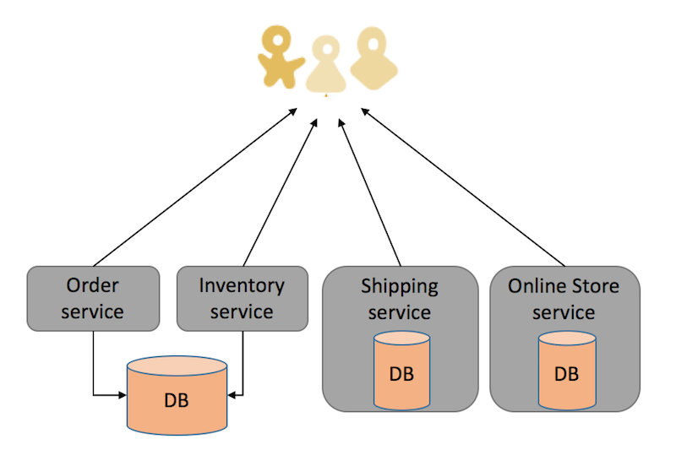

SOA

A Service Oriented Architecture is a software architecture pattern, which application components provide services to other components via a communications protocol over a network. The communication can involve either simple data passing or it could involve two or more services coordinating connecting services (Web Servics) to each other. Services (such as RESTful Web services) carry out some small functions, such as validating an order, activating account, or providing shopping cart services.

There are 2 main roles in SOA, a service provider and a service consumer.

A software agent may play both roles. The Consumer Layer is the point where consumers (human users, other services or third parties) interact with the SOA and Provider Layer consists of all the services defined within the SOA. The following figure shows a quick view of an SOA architecture.

Enterprise Service Bus (ESB) is a style of the integration architecture that allows communication via a common communication bus that consists of a variety of point-to-point connections between providers and consumers . In addition to above, the data storage is shared within all services in SOA.

So, SOA is an architectural pattern in which application components provide services to other components. Autonomous units of business functionality: each service provides a business function that is independent of other services.

UI Code Architecture - REACT

